HILLS BOWLING ASSOCIATION (formerly Hills Men’s Bowling Association)
CHAMP OF CHAMP WINNERS ( * denotes Divisional Winner)

YEAR |  | SINGLES | PAIRS | FOURS
20.8.49
50/51
51/52
52/53 |  | W. (Bill) Jantke (Lob)
53/54 |  | J. Brecht (Lob)
54/55 |  | J. Brecht (Lob)
55/56 |  | J. Brecht (Lob)
56/57 |  | M. Plummer (Lob)
57/58 |  | J. Ween (Man)
58/59 | 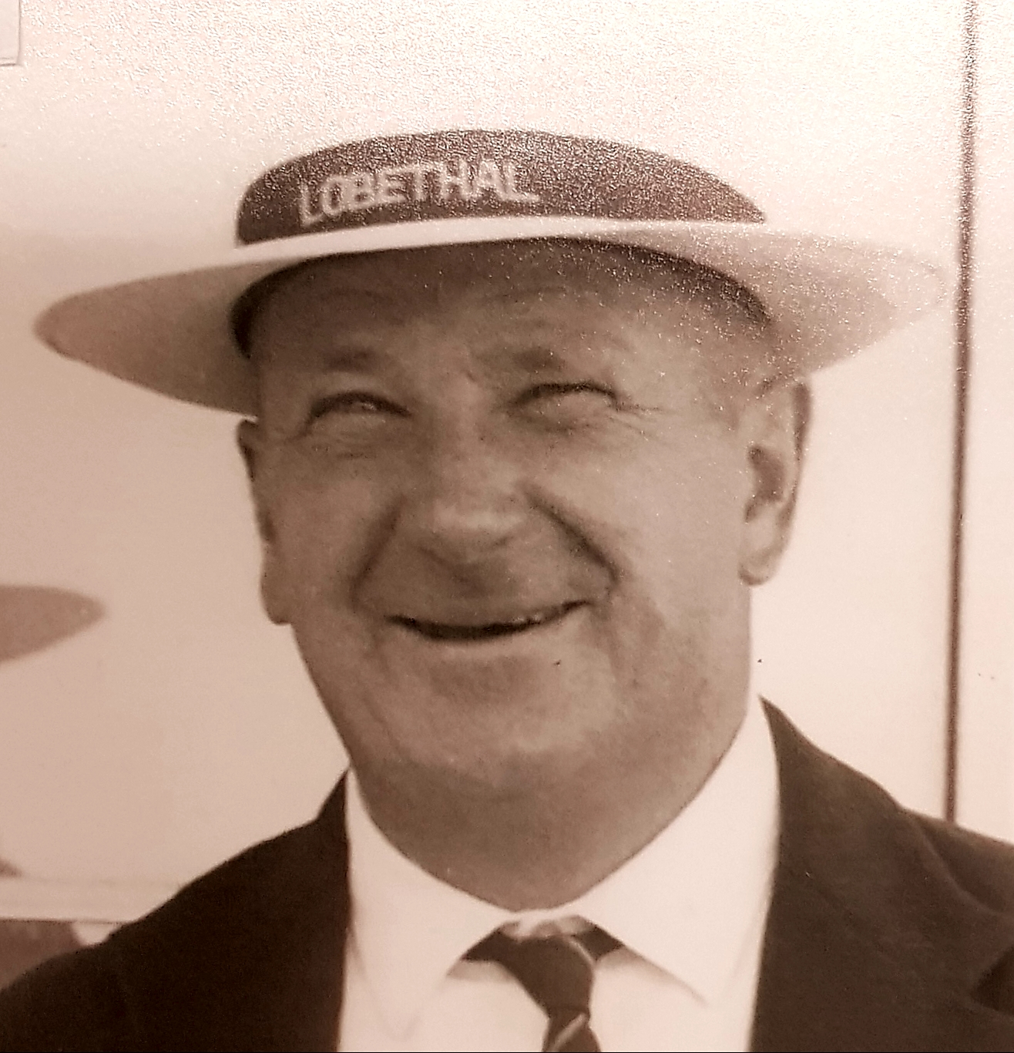 | W. (Bill) Jantke (Lob)
59/60 |  | W. (Bill) Jantke (Lob)
60/61 |  | K. Robinson (Onk)
61/62 |  | R. Gartrell (Man)
62/63 |  | Ray Fuller (Gum)
63/64 | 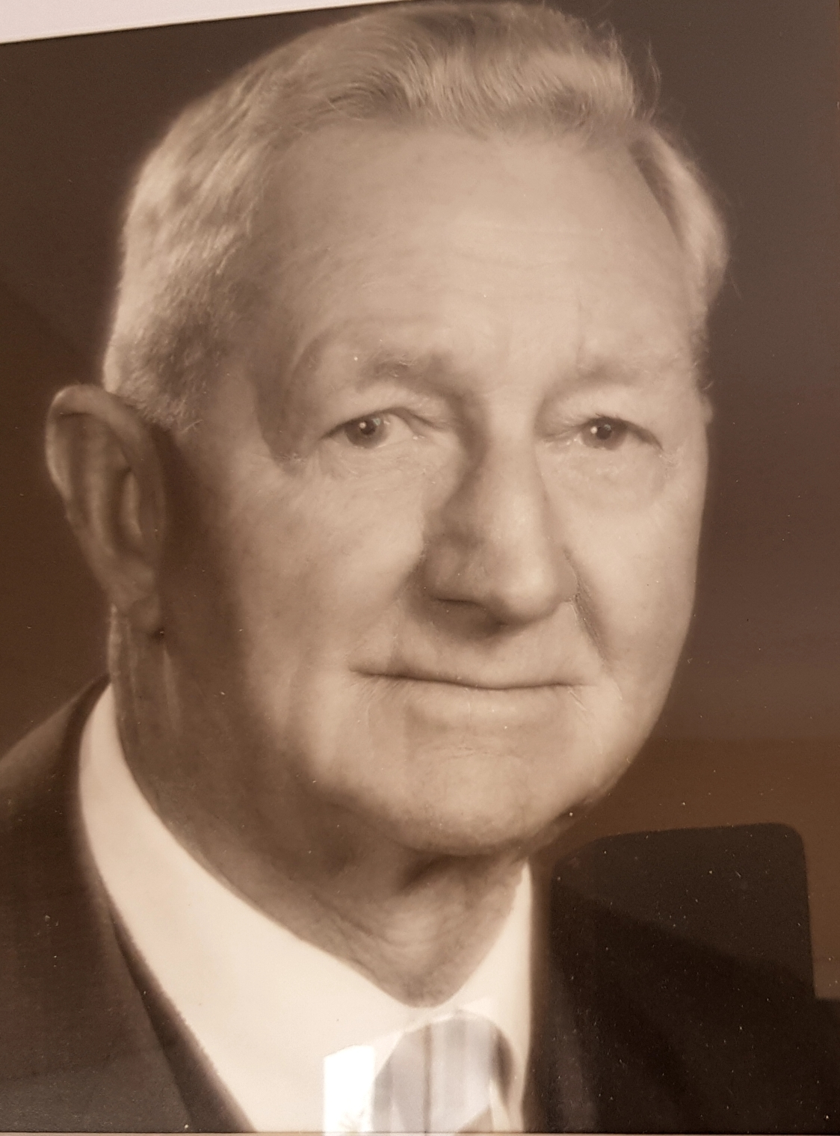 | A. (Bert) Copeland (Lens) *
64/65 |  | Phil Herriot (MP)
65/66 | 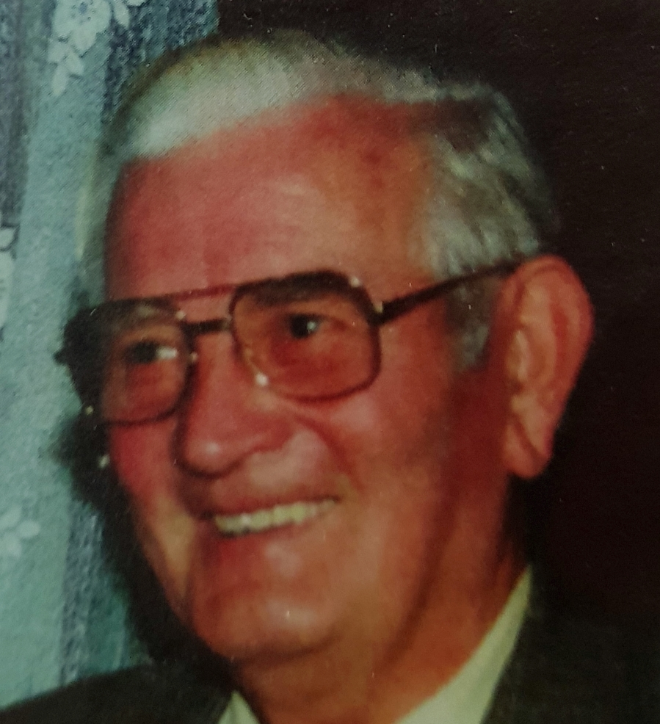 | Ray Fuller (Gum)
66/67 | 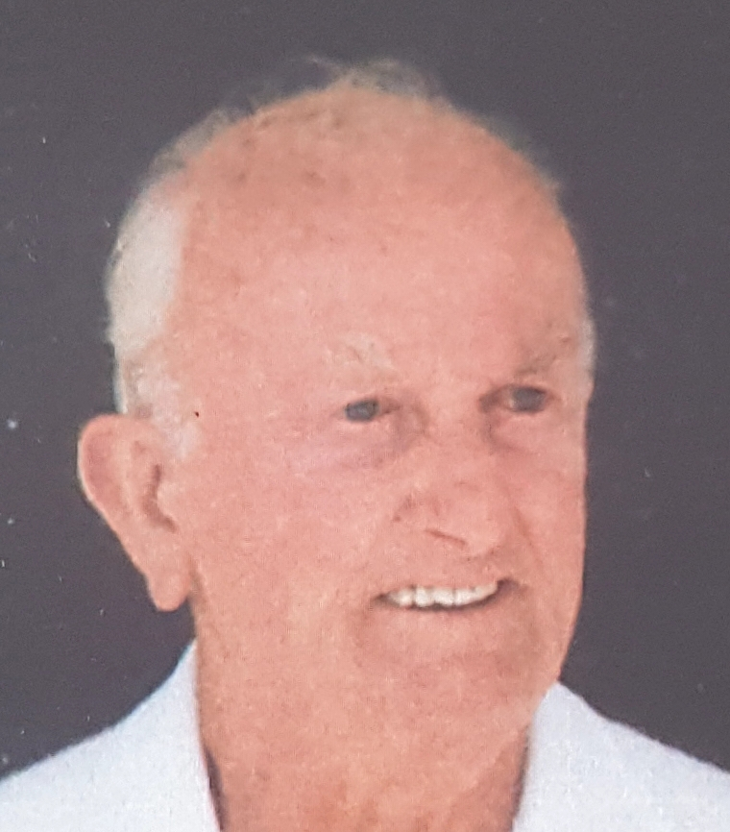 | Phil Herriot (MP)
67/68 |  | Phil Herriot (MP) *
68/69 |  | J. McDiarmid (Man)
69/70 |  | R. Wakefield (Man)
70/71 |  | Phil Herriot (MP)
71/72 |  | V. Heinze (Wood)
72/73 | 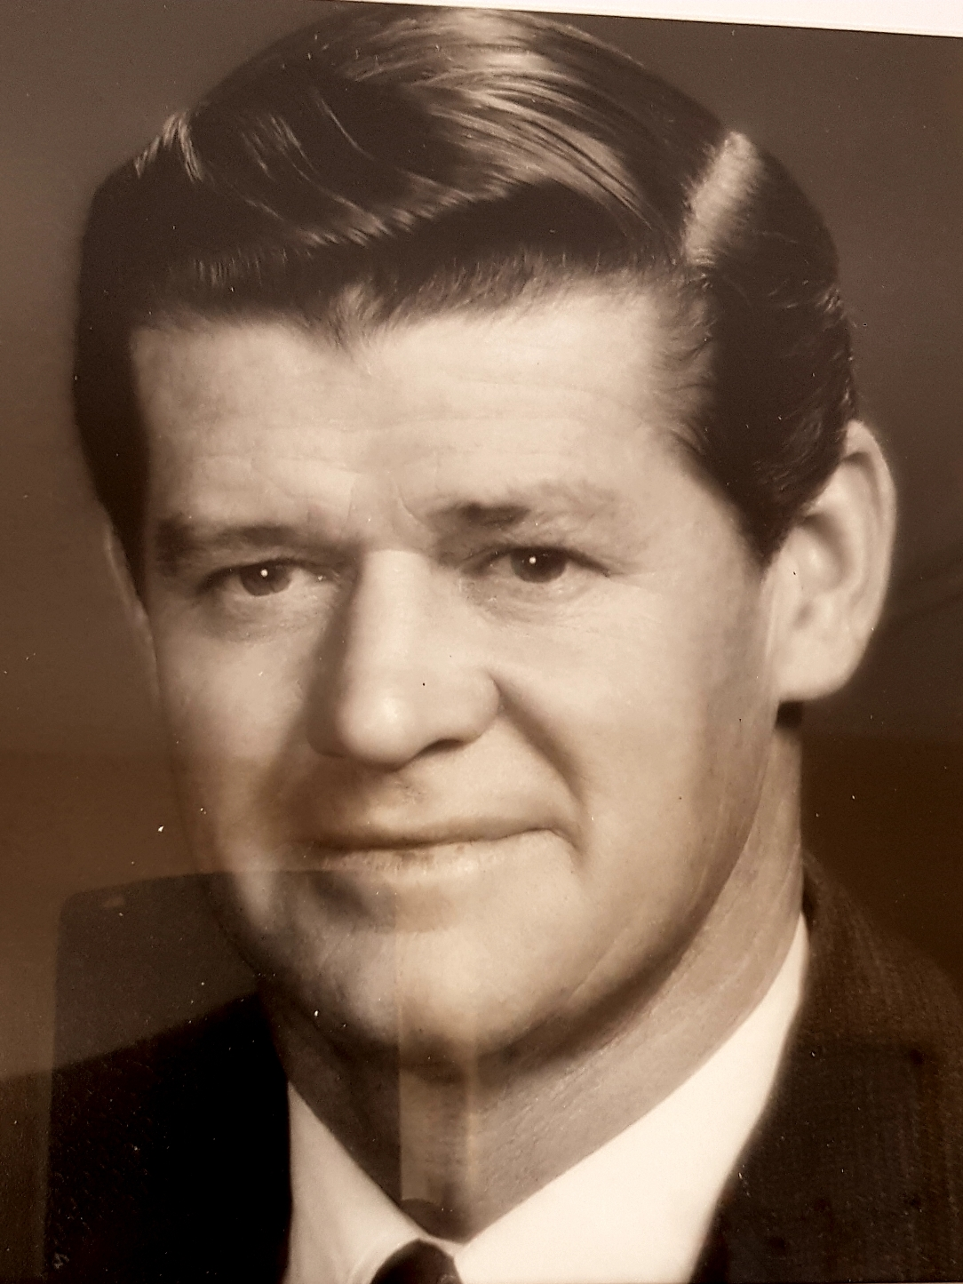 | P. Trevenen (Lens)
73/74 |  | R. Pfeiffer (Onk)
74/75 |  | P. Trevenen (Lens)
75/76 |  | Phil Herriot (MP) *
76/77 |  | P. Noble (Man) *
77/78 |  | Phil Herriot (MP)
78/79 |  | R. Green (Gum) | G. Smith, H. Martin (Wood) | S. Plummer, R. Mason, K. Filsell, S. Baker (Lens)
79/80 |  | Phil Herriot (MP) * | J. Rundle, B. Schutz (MP)
80/81 | 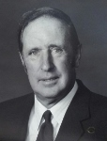 | Noel Green (Lens) * | W. Murdoch, C. Meikle (Lens) | J. Rundle, C. Newman, L. Porter, D. Hartree (MP)
81/82 |  | Phil Herriot (MP) * | R. Fuller, L. Fuller (Gum) | R. Wakefield, N. Bolto, G. Evans, M. Bottroff (Man) *
82/83 |  | Phil Herriot (MP)
83/84 |  | Noel Green (Lens) | H. Taylor, G. Bartsch (MP)
84/85 | 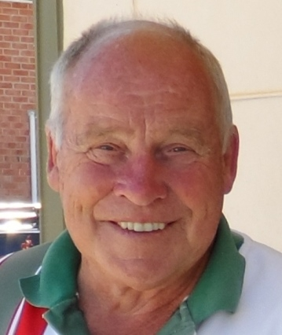 | Warren Murdoch (Lens) * | F. Fidler, C. Bruce, A. Hyde sub (Man) | U. Freidenfelds, G. Weyland, C. Suffolk, R. Russell (Lob)
85/86 |  | M. Prosser (Wood) | K. Filsell, S. Baker (Lens) | H. Taylor, C. Newman, N. Evans, W. Kluge (MP)
86/87 |  | P. Assender (Gum) | R. Bungay, P. Hartmann (Wood) * | L. Fuller, B. Mullins, S. Miller, D. Levett (Gum)
87/88 |  | Trevor Zilm (Lob) | F. Fidler, P. Noble (Man) | J. Pitcher, G. Evans, N. Bolto, C. Tabe (Man)
88/89 |  | W. McMurtrie (Wood) | P. Herriot, V. Carnell (MP) | L. Fuller, B. Mullins, P. Assender, R. Coleman (Gum)
89/90 |  | F. Fidler (Man) | P. Hartmann, P. Mangelsdorf (Wood) | T. Zilm, G. Weyland, N. Mansell, K. Oborn (Lob)
90/91 | 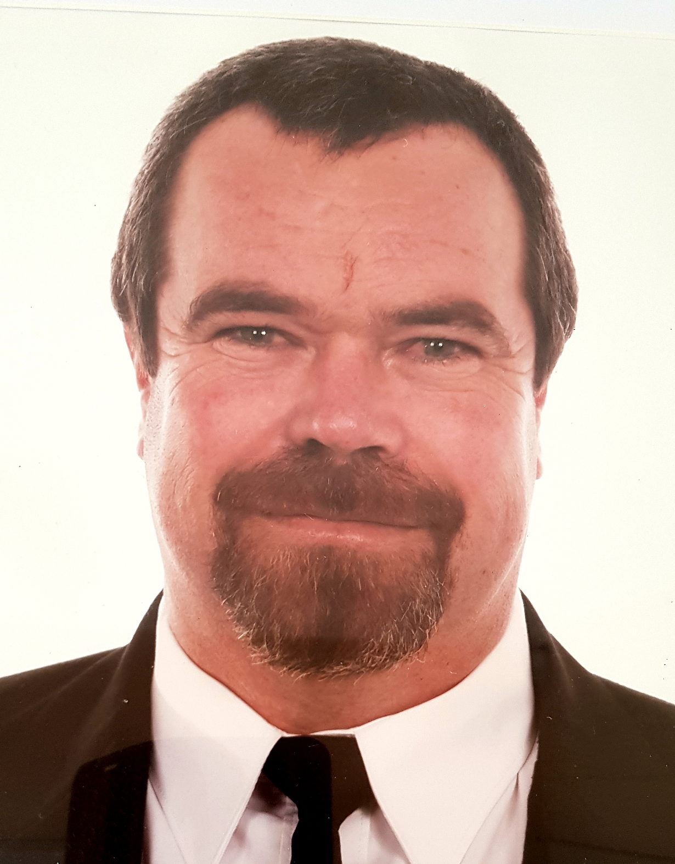 | L. Meikle (Lens) | J. Pitcher, C. Tabe (Man) | G. Weyland, N. Mansell, K. Oborn, K. Fox (Lob)
91/92 |  | P. Herriot (MP) * | M. Pietsch, B. Norman (Wood) | W. Murdoch, S. Baker, I. Schultz, K. Filsell (Lens) *
92/93 |  | Trevor Zilm (Lob)* | P. Mangelsdorf, S. Badenoch (Wood) | D. Cathro, P. Hartman, A. Bradbrook, B. Norman (Wood)*
93/94 |  | Wally Crabbe (Gum) | S. Baker, K. Filsell (Lens) | U. Freidenfelds, N. Mansell, K. Oborn, K. Fox (Lob)
94/95 |  | N. Evans (MP) | T. Zilm, K. Schulz (Lob) | G. Weyland, N. Mansell, C. De Vries, J. McBrien
95/96 |  | Peter Mangelsdorf (Wood) | B. Briand, K. Burgess (Stirling) | K. Bolto, G. Alberd, A. Dalton, M. Delany (Oak)*
96/97 |  | Colin Mangelsdorf (Wood) | N. Green, G. Thomas (Lens) | T. Zilm, G. Weyland, K. Schulz, K. Fox (Lob)
97/98 |  | Trevor Zilm (Lob) | N. Mansell, K. Schulz (Lob) * | S. Baker, W. Murdoch, R. Caldicott, G. Thomas (Lens)*
98/99 | 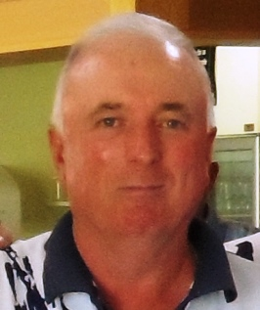 | Steve Baker (Lens) | K. Bolto, T. Murphy (Lens) | P. Thompson, E. Deane, K. Dewell, D. Warner (MP)
99/00 |  | David Faehrmann (MtB) | S. Baker, L. Meikle (Lens)* | P. Thompson, T. Woolford, K. Dewell, R. Jantke (MP)*
00/01 |  | Laurie Meikle (Lens)* | T. Zilm, W. Zilm (Lob) | A. Schultz, G. Alberd, K. Bolto, K. Schultz (Lens)
01/02 |  | P. Thompson (MP) | C. Oborn, F. Dorr (Gum) | A. Alberd, G. Alberd, T. Luke, W. Murdoch (Lens)*
02/03 | 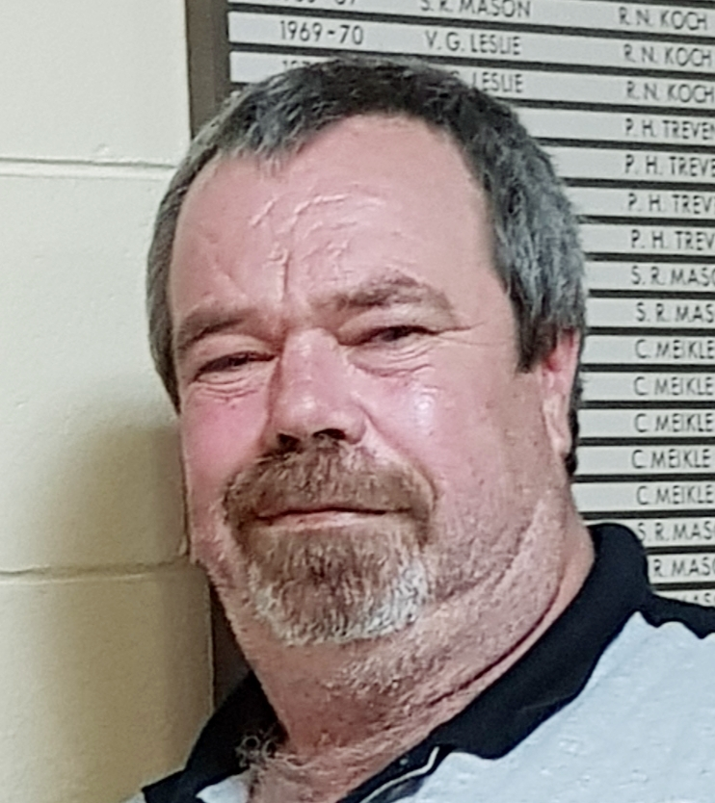 | Laurie Meikle (Lens) | S. Baker, L. Meikle (Lens)* | S. Baker, G. Alberd, W. Murdoch, K. Bolto (Lens)
03/04 | 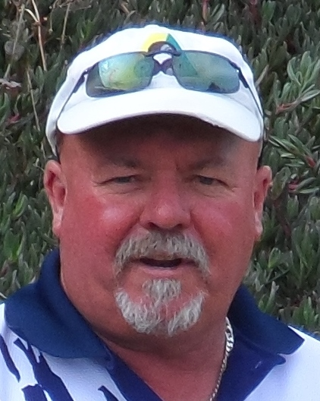 | Peter Mangelsdorf (Wood) | S. Baker, L. Meikle (Lens) | D. Male, L. Gherghetta, B. McAllister, D. Hartland (Mead)
04/05 | 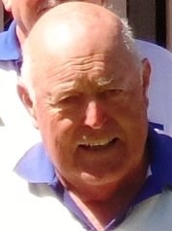 | David Chapman (MtB) | L. Fuller, R. Faehrmann (Gum) | P. Mangelsdorf, B. Norman, D. Cathro, L. Thomas (Wood)
05/06 | 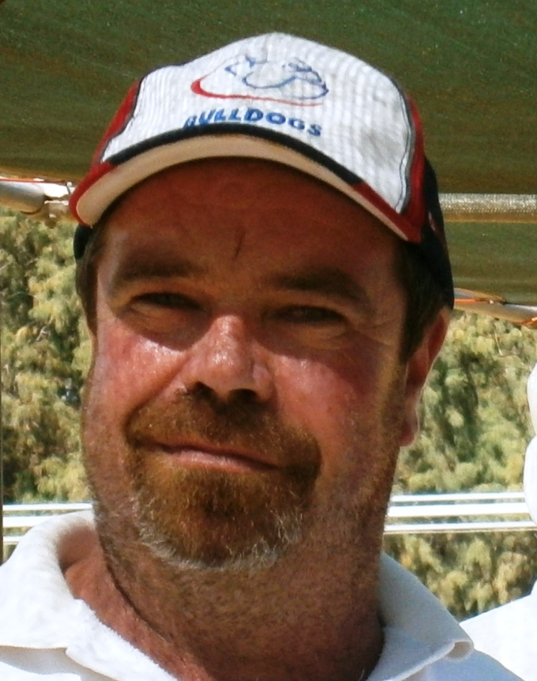 | Laurie Meikle (Lens) | D. Chapman, D. Faehrmann (MtB) | P Mangelsdorf, B.Norman, S.Thomas, T.Fitzgerald (Wood)
06/07 |  | Laurie Meikle (Lens) | W. Zilm, N. Mansell (Lob) | L. Fuller, F. Dorr, T. Mik, R. Faehrmann (Gum)
07/08 |  | Laurie Meikle (Lens) | S. Jones, A. Daw (MtB) | P. Mangelsdorf, L. Harrison, G. Alberd, A. Day (Wood)
HILLS BOWLING ASSOCIATION – OPEN GENDER

08/09 | 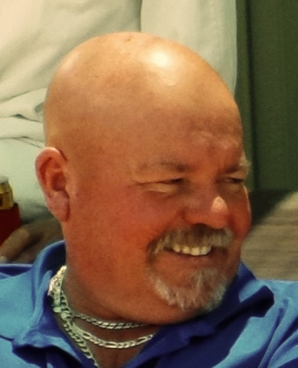 | Peter Mangelsdorf (Wood) | S. Jones, A. Daw (MtB) | N. Mansell, K. Schulz, P. Stanbury, S. Dienelt (Lob)
09/10 | 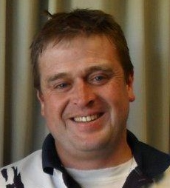 | Brett Norman (Wood) | N. Mansell, W. Zilm (Lob) | D. Faehrmann, J. Corner, R. Babidge, R. Davis (MtB)
10/11 |  | Brett Norman (Wood) | W. Zilm, B. Pingel (Lob) | I. Cockroft, S. Marshall, A. McLachlan, K. McGee (MP)
11/12 | 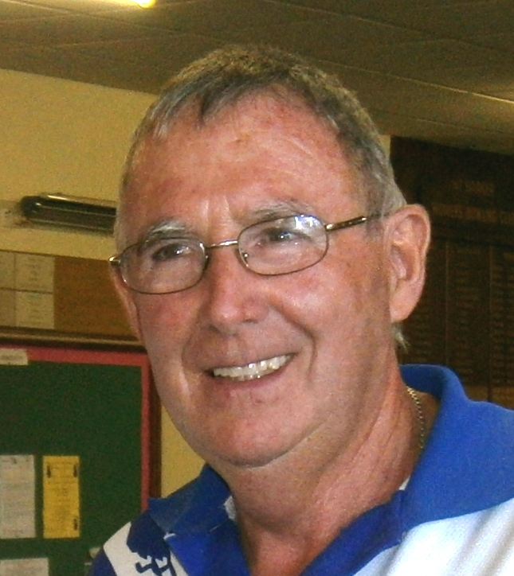 | John Corner (MtB) | B. Norman, D. Norman (Wood) | J. Corner, R. Elder, G. Saunders, G. Moyle (MtB)
12/13 | 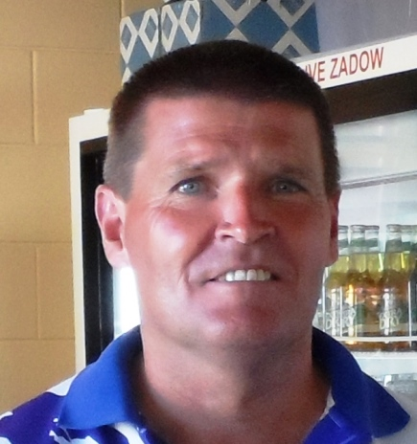 | Tony Wetherall (MtB) * | J. Vickers, B. Scown (Lens) | P. O’Shaugnessy, S. Wakefield, H. Feijen, D. Wuttke (Ur)
13/14 |  | Barry Rowe (Gumeracha) | John Corner, Tony Wetherall (Mt.B). | P. O’Shaugnessy, S. Wakefield, H. Feijen, D. Wuttke (Ur)
14/15 | 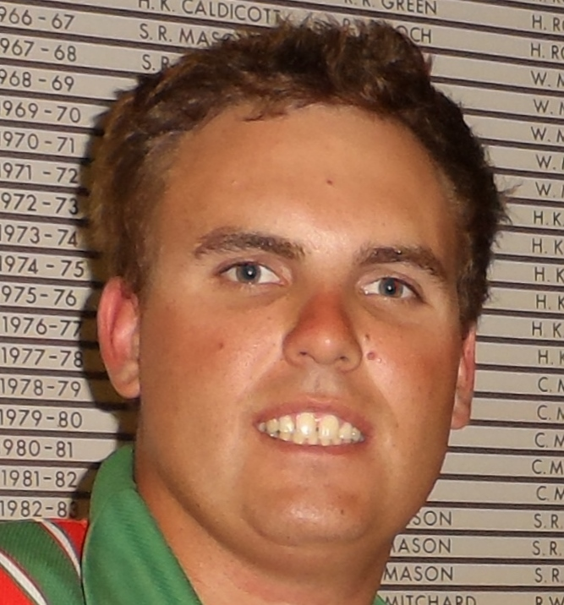 | Men’s Singles – Jarrod Pittaway (Lenswood) |  | Women’s Singles – Christine Keller (Hahndorf) | 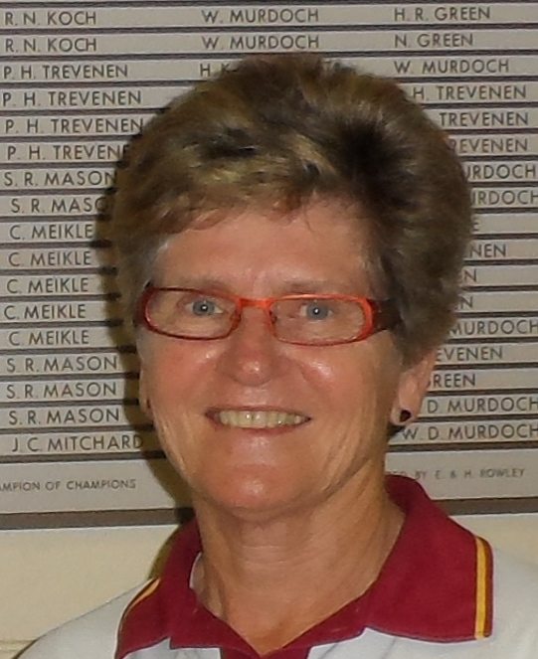 | 14/15
14/15 |  | Men’s Pairs – D. Chapman, D. Evans (Mt. Barker) |  | Women’s Pairs – P. Eichner, C. Keller (Hahndorf) |  | 14/15
14/15 |  |  |  | Women’s Triples – P. Eichner, J. Wagnitz, C. Keller (Hahndorf |  | 14/15
14/15 |  | Mens’ Fours – A. Heppner, L. Meikle, A. Theile, B. Fiddes (Oakbank) |  | Women’s Fours – D. Honson, M. Nenke, P. Vorwerk, D. Lee (Mt. Barker) |  | 14/15
15/16 | 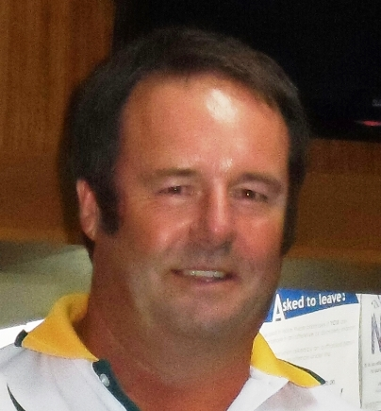 | Men’s Singles – Neville Mansell (Lobethal) |  | Women’s Singles – Christine Keller (Hahndorf) | 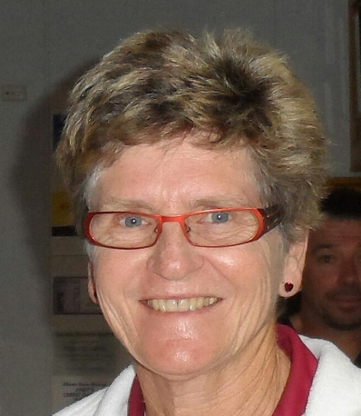 | 15/16
15/16 |  | Men’s Pairs – Wayne Zilm, Darren Stanbury (Lobethal) |  | Women’s Pairs – Kathryn Atkinson, Feli Sandercock (Gumeracha). |  | 15/16
15/16 |  | Open Triples – Fred Dorr, Craig Oborn, Roger Faehrmann (Gumeracha) |  |  |  | 15/16
15/16 |  | Open Fours – Peter Mangelsdorf, Brett Norman, Anthony Day, Bob Hahesy (Woodside). |  |  |  | 15/16
16/17 |  | Men’s Singles – Luke West (Mt Pleasant) |  | Women’s Singles – Kathy Miller (Hahndorf) | 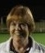 | 16/17
16/17 |  | Men’s Pairs – David Moate, Arthur Scott (Oakbank) |  | Women’s Pairs – Christine Keller, Carolyne Edwardes (Hahndorf) |  | 16/17
16/17 |  | Open Triples – Damian Havriluk, Anthony Treloar, Joe Conte, (Lobethal) |  |  |  | 16/17
16/17 |  | Open Fours – John Corner, Tony Wetherall, Raelene Corner, Christine Nicholls, (Mt Barker) |  |  |  | 16/17
17/18 | 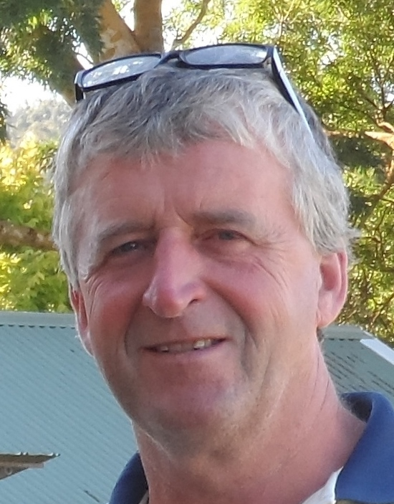 | Men’s Singles – David Gleeson (Uraidla) |  | Women’s Singles – Alex Reynolds (Woodside) | 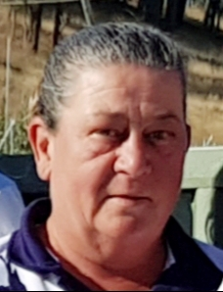 | 17/18
17/18 |  | Men’s Pairs – Wayne Zilm, Mal Jonas (Lobethal) |  | Women’s Pairs – Christine Keller, Carolyne Edwardes  (Hahndorf) |  | 17/18
17/18 |  | Open Triples – Anthonay Treloar, Joe Conte, Damian Havriluk (Lobethal) |  |  |  | 17/18
17/18 |  | Open Fours – Roger Faehrmann, Fred Dorr, Bernie Mullins, S. Knipe. (Gumeracha) |  |  |  | 17/18
18/19 | 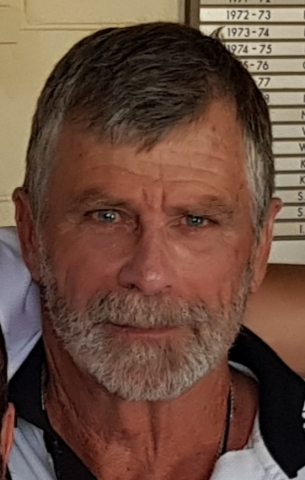 | Men’s Singles – Craig Oborn (Gumeracha) |  | Women’s Singles – Kathy Miller ( Oakbank)* | 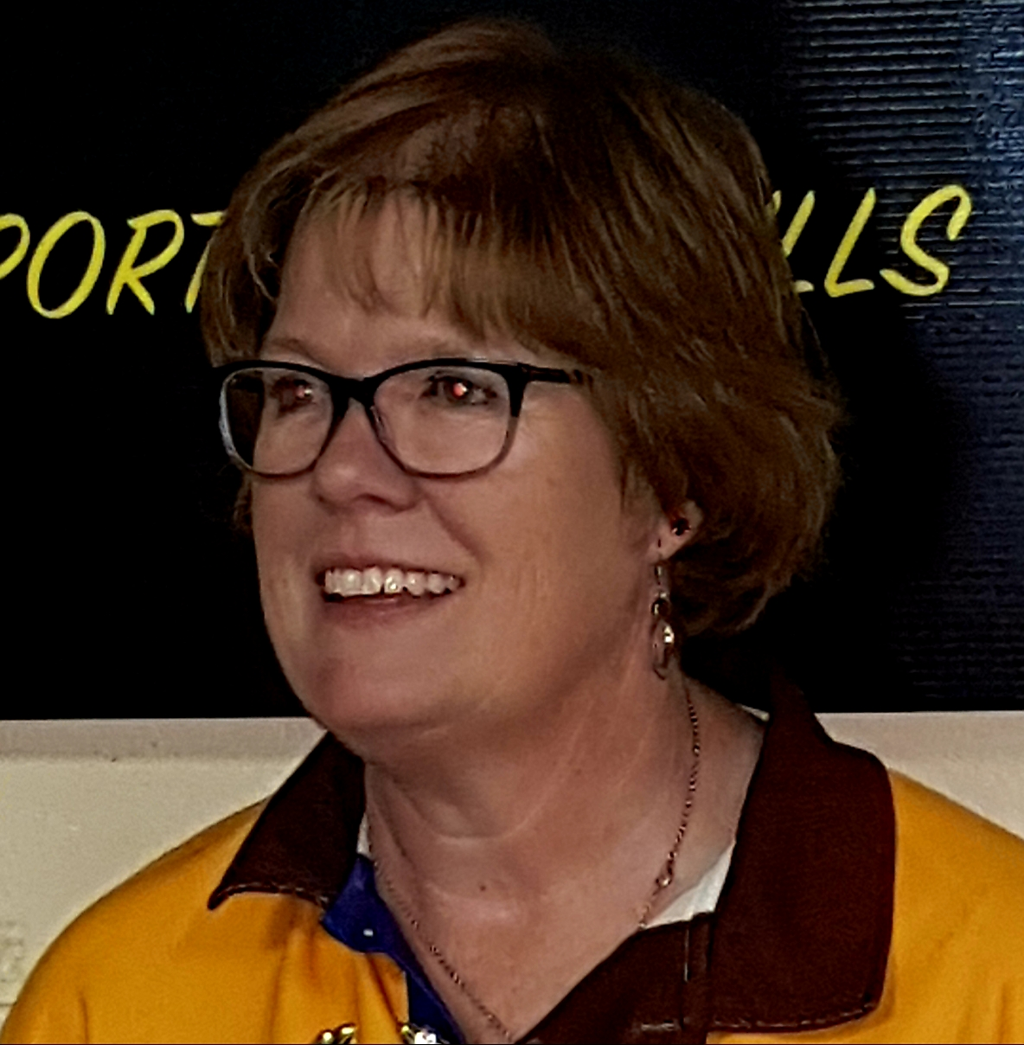 | 18/19
 |  | Men’s Pairs – Bob Edwards, Ray Rattray (Hahndorf) |  | Women’s Pairs – Carol Thomson, Bev Gerick (Lobethal)*
 |  | Open Triples – John Corner, Tony Weatherall, Christine Nicholls (Mt Barker)
 |  | Open Fours – Guy Stanley, Paul Van De Water, Brett Carter, Kym Shillabeer (Oakbank)

19/20 |  | Men’s Singles – Andrew (Andy) Alberd (Woodside) | Women’s Singles – Julia Gadsdon (Woodside) |  | 19/20
 |  | Men’s Pairs – Neville Mansell, Joe Conte (Lobethal) | Women’s Pairs – Sheryl Joseph, Sandy Hole (Meadows)
 |  | Open Triples – Wayne Zilm, Damian Havriluk, Joe Conte (Lobethal)
 |  | Open Fours – Darren Stanbury, Neville Mansell, Paul Maloney, Kelley Stanbury (Lobethal)

20/21 |  | Men’s Singles - | Women’s Singles - |  | 20/21
 |  | Men’s Pairs - | Women’s Pairs -
 |  | Open Triples -
 |  | Open Fours -

21/22 |  | Men’s Singles - | Women’s Singles - |  | 21/22
 |  | Men’s Pairs - | Women’s Pairs -
 |  | Open Triples -
 |  | Open Fours -

22/23 |  | Men’s Singles - | Women’s Singles - |  | 22/23
 |  | Men’s Pairs - | Women’s Pairs -
 |  | Open Triples -
 |  | Open Fours -

