HILLS BOWLING ASSOCIATION – EXECUTIVE COMMITTEE

Life Members – Noel Green, Merv Miles, Warren Murdoch, John McBrien, Graham Weyland

YEAR | PATRON | PRESIDENT | SEN. VICE PRESIDENT | JUN. VICE PRESIDENT | SECRETARY/  TREASURER | TREASURER | EXECUTIVE MEMBERS (including Immediate Past Presidents).
20.8.49 | O. Nelsen | M. E. Howland | A. Hicks | C. G. Mason | L. H. Harrison
50/51 | O. Nelsen | M. E. Howland | A. Hicks | C. G. Mason | L. H. Harrison
51/52 | T. J. Hannam | F. W. Jantke | A. Hicks | C. G. Mason | L. H. Harrison
52/53 | T. J. Hannam | F. W. Jantke | C. G. Mason | K. Johns | L. H. Harrison
53/54 | T. J. Hannam | F. W. Jantke | C. G. Mason | J. C. Symonds | J. A. Morcom
54/55 | T. J. Hannam | K. Johns | C. G. Mason | J. C. Symonds | J. A. Morcom
55/56 | T. J. Hannam | K. Johns | C. G. Mason | J. C. Symonds | J. A. Morcom
56/57 | T. J. Hannam | C. G. Mason | J. C. Symonds | L. C. Mattner | J. A. Morcom
57/58 | T. J. Hannam | C. G. Mason | J. C. Symonds | L. C. Mattner | J. A. Morcom
58/59 | T. J. Hannam | J. C. Symonds | L. C. Mattner | A. Tabe | W. Brokate
59/60 | F. W. Jantke (Lob) | J. C. Symonds | L. C. Mattner | A. Tabe | R. J. Martin
60/61 | F. W. Jantke (Lob) | L. C. Mattner | A. Tabe | E. H. Ross | R. J. Martin
61/62 | F. W. Jantke (Lob) | L. C. Mattner | A. Tabe | E. H. Ross | J. A. Morcom
62/63 | F. W. Jantke (Lob) | A. Tabe | G. D. Perrin | O. Dankel | J. A. Morcom
63/64 | F. W. Jantke (Lob) | A. Tabe | G. D. Perrin | O. Dankel | J. A. Morcom
64/65 | F. W. Jantke (Lob) | G. D. Perrin | C. O’Malley | G. Deane | J. A. Morcom
65/66 | F. W. Jantke (Lob) | G. D. Perrin | C. O’Malley | L. Cowling | R. J. Martin
66/67 | F. W. Jantke (Lob) | C. O’Malley | L. Cowling | R. M. Koch | R. J. Martin
67/68 | F. W. Jantke (Lob) | C. O’Malley | L. Cowling | R. M. Koch | R. J. Martin
68/69 | F. W. Jantke (Lob) | L. Cowling | R. M. Koch | H. F. Dohnt | R. M. Koch
69/70 | F. W. Jantke (Lob) | L. Cowling | R. M. Koch | H. F. Dohnt | R. M. Koch
70/71 | F. W. Jantke (Lob) | R. M. Koch | H. F. Dohnt | C. G. Bruce | S. R. Mason
71/72 | F. W. Jantke (Lob) | R. M. Koch | H. F. Dohnt | C. G. Bruce | S. R. Mason
72/73 | F. W. Jantke (Lob) | C. G. Bruce | H. F. Dohnt | L. H. Spoehr | E. G. Bottroff
73/74 | F. W. Jantke (Lob) | C. G. Bruce | H. F. Dohnt | L. H. Spoehr | E. G. Bottroff |  | P. Herriot, R. Trenerry
74/75 | F. W. Jantke (Lob) | H. F. Dohnt | L. H. Spoehr | V. Heinze | R. Trenerry |  | P. Herriot, E. G. Bottroff
75/76 | F. W. Jantke (Lob) | H. F. Dohnt | L. H. Spoehr | V. Heinze | R. Trenerry |  | E. G. Bottroff, V. Heinze
76/77 | F. W. Jantke (Lob) | L. H. Spoehr | V. Heinze | B. Zilm | R. Trenerry |  | P. Herriot, E. G. Bottroff
77/78 | F. W. Jantke (Lob) | L. H. Spoehr | V. Heinze | B. Zilm | R. Trenerry |  | P. Herriot, E. G. Bottroff
78/79 | F. W. Jantke (Lob) | V. Heinze | B. Zilm | M. J. Groth | D. Scott |  | P. Herriot, P. Trevenen
79/80 | F. W. Jantke (Lob) | V. Heinze | M. J. Groth | N. Green | D. Scott |  | L. H. Spoehr (PP)
80/81 | F. W. Jantke (Lob) | M. J. Groth | N. Green | J. R. Pitcher | J. L. Rundle |  | P. Trevenen, V. Heinze (PP)
81/82 | F. W. Jantke (Lob) | M. J. Groth | N. Green | J. R. Pitcher | J. L. Rundle |  | P. Trevenen, V. Heinze (PP)
82/83 | F. W. Jantke (Lob) | N. Green | J. R. Pitcher | B. Gorman | C. Meikle |  | M. J. Groth (PP)
83/84 | F. W. Jantke (Lob) | N. Green | J. R. Pitcher | B. Gorman | C. Meikle |  | M. J. Groth (PP)
84/85 | F. W. Jantke (Lob) | J. R. Pitcher | B. Gorman | R. Klose | W. D. Chadwick |  | C. Meikle, N. Green (PP)
85/86 | H. B. Westphalen (MP) | J. R. Pitcher | W. Murdoch | R. Klose | W. D. Chadwick |  | C. Meikle, N. Green (PP)
86/87 | H. B. Westphalen (MP) | W. Murdoch | G. L. Weyland | M. H. Miles | C. Meikle |  | J. R. Pitcher (PP)
87/88 | H. B. Westphalen (MP) | W. Murdoch | G. L. Weyland | M. H. Miles | U. Freidenfelds |  | J. R. Pitcher (PP)
88/89 | H. B. Westphalen (MP) | G. L. Weyland | M. H. Miles | W. Ellis | U. Freidenfelds |  | W. Murdoch (PP)
89/90 | H. B. Westphalen (MP) | G. L. Weyland | M. H. Miles | W. Ellis | U. Freidenfelds |  | C. Meikle, W. Murdoch (PP)
90/91 | H. B. Westphalen (MP) | M. H. Miles | W. Ellis | C. Meikle | U. Freidenfelds |  | W. Murdoch, G. L. Weyland (PP)
91/92 | H. B. Westphalen (MP) | M. H. Miles | W. Ellis | C. Meikle | U. Freidenfelds |  | W. Murdoch, G. L. Weyland (PP)
92/93 | H. B. Westphalen (MP) | C. Meikle | W. Mayes | T. N. Frahn | J. R. Pitcher |  | M. H. Miles (PP)
93/94 | L. C. Strout (Oakbank) | M. H. Miles | J. Schultz | A. Bradbrook | J. W. McBrien | W. Murdoch | C. Meikle (PP)
94/95 | L. C. Strout (Oakbank) | A. Bradbrook | J. Schultz | A. Murphy | J. W. McBrien |  | M. H. Miles (PP)
95/96 | L. C. Strout (Oakbank) | A. Bradbrook | A. Murphy | G. L. Weyland | J. W. McBrien |  | M. H. Miles (PP)
96/97 | L. C. Strout (Oakbank) | A. Murphy | A. Craig | T. Woolford | J. W. McBrien |  | A. Bradbrook (PP)
97/98 | L. C. Strout (Oakbank) | A. Murphy | A. Craig | K. Schulz | J. W. McBrien |  | A. Bradbrook (PP)
98/99 | L. C. Strout (Oakbank) | K. Schulz | R. H. Caldicott | K. Cooper | J. W. McBrien |  | A. Murphy (PP)
99/00 | L. C. Strout (Oakbank) | K. Schulz | R. H. Caldicott | K. Cooper | J. W. McBrien |  | A. Murphy (PP)
00/01 | L. C. Strout (Oakbank) | R. H. Caldicott | T. McNamara | K. Schulz | J. W. McBrien |  | K. Schulz (PP)
01/02 | B. Vickers (Lens) | R. H. Caldicott | K. Schulz | N. Ingram | J. W. McBrien |  | K. Schulz (PP)
02/03 | B. Vickers (Lens) | N. Ingram | G. Alberd | R. Faehrmann | J. W. McBrien |  | R. H. Caldicott (PP)
03/04 | B. Vickers (Lens) | N. Ingram | G. Alberd | R. Faehrmann | J. W. McBrien |  | R. H. Caldicott (PP)
04/05 | B. Vickers (Lens) | R. Faehrmann | A. Murphy | J. Grant | J. W. McBrien |  | N. Ingram (PP)
05/06 | B. Vickers (Lens) | R. Faehrmann | G. L. Weyland | J. Grant | J. W. McBrien |  | N. Ingram (PP)
06/07 | B. Vickers (Lens) | G. L. Weyland | G. Alberd |  | J. W. McBrien |  | R. Faehrmann (PP)
07/08 | B. Vickers (Lens) | G. L. Weyland | G. Alberd | T. Stephen | J. W. McBrien | R. Symons | B. O’Gallagher, R. Faehrmann (PP)
08/09 | B. Vickers (Lens) | G. Alberd | M. Dew | J. Conte | J. W. McBrien | T. Stephen | W. Murdoch, G. L. Weyland (PP)
09/10 | M. Miles (Gum) | G. Alberd | M. Dew | J. Conte | R. Faehrmann | T. Stephen | W. Murdoch, G. L. Weyland (PP)
10/11 | M. Miles (Gum) | J. Conte | G. L. Weyland | W. Lee | R. Faehrmann | T. Stephen | W. Murdoch, G. Alberd (PP)
11/12 | M. Miles (Gum) | W. Lee | G. Sloan | R. Faehrmann | M. Jonas/T. Stephen | T. Stephen | G. L. Weyland, G. Alberd (PP)
12/13 | M. Miles (Gum) | W. Lee | F. Dorr | R. Faehrmann | T. Stephen |  | G. L.Weyland, G. Matthews, G. Alberd (PP)
13/14 | M. Miles (Gum) | W. Lee | F. Dorr | R. Faehrmann | T. Stephen |  | G. L. Weyland, H. Fels, G. Alberd (PP)
14/15 | M. Miles (Gum) | F. Dorr | R. Faehrmann | G. Weyland | T. Stephen |  | H. Fels, B. Young, W. Lee (PP)
15/16 | M. Miles (Gum) | F. Dorr | R. Faehrmann | G. Weyland | T. Stephen |  | B. Young, A. Reynolds, W. Lee (PP)
16/17 | M. Miles (Gum) | G. Weyland | W. Lee |  | J. W. McBrien | A. Pobke | W. Mayes, B. Hopkins, H. Sime.
17/18 | M. Miles (Gum) | G. Weyland | W. Lee |  | J. W. McBrien | A. Pobke | B. Young, B. Hopkins, H. Sime.
18/19 | M. Miles (Gum) | G.Weyland | V. Deeble |  | J. W. McBrien | A. Pobke | B. Young, B. Hopkins*, H. Sime*,H. Fels.
19/20 | M. Miles (Gum) | G. Weyland | V. Deeble |  | J. W. McBrien | A. Pobke | B. Young, R. Faehrmann, T. Stephen, H. Fels*
20/21 | M. Miles (Gum) | T. Mik | D. Fuda |  | T. Stephen | A. Pobke | R. Faehrmann, J. Ridge
21/22 | Merv and Kath Miles (Gum) | T. Mik | D. Fuda |  | T. Stephen | A. Pobke | W. Lee, G. Weyland, V. Deeble,  R. Faehrmann (Ass. Sec).
22/23 | Merv and Kath Miles (Gum) | T. Mik | D. Fuda |  | T. Stephen | A. Pobke | W. Lee, G. Weyland, V. Deeble.
23/24 | Merv and Kath Miles (Gum) | D. Fuda | A. Reynolds |  | T. Stephen | A. Pobke | V. Deeble, B. Lenny, M. Guerin
24/25 | Merv and Kath Miles (Gum) | D. Fuda | A. Reynolds |  | T. Stephen | A. Pobke | V. Deeble, B. Lenny, R. Jarman

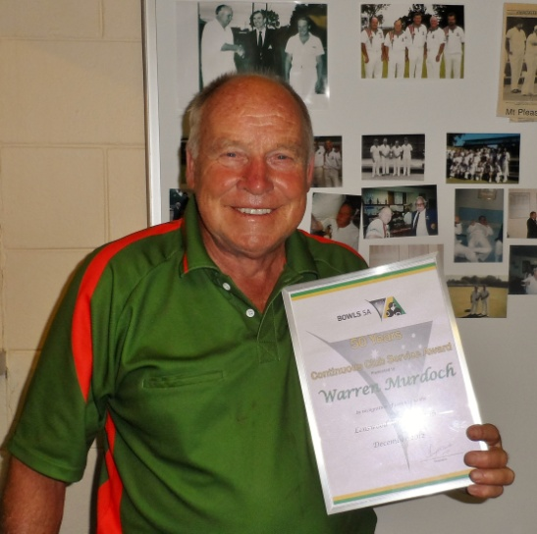 | Warren Murdoch  Warren commenced playing with the Lenswood Bowling Club in 1963 at the age of 22. Warren has served his club and the association loyally since then, adding HBA life membership to his club honours. He has served on the HBA Executive committee in various roles over a period of 25 years. Warren was further lauded in 2013 for achieving 50 years in lawn bowls, with the presentation coinciding with the 28th annual Warren Murdoch invitational tournament, held at the Lenswood BC.
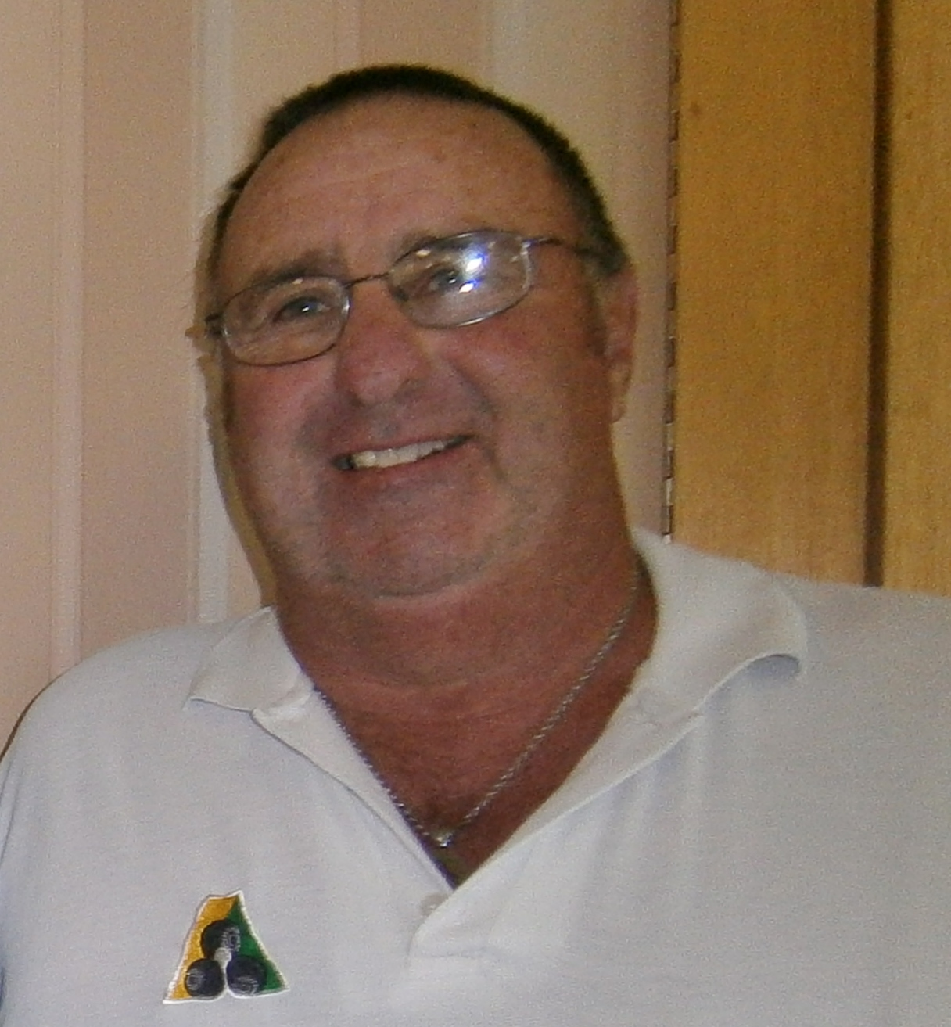 | Graham Weyland  Graham is a longstanding member of the Lobethal Bowling Club. He has enjoyed enormous success at both club and association level. He commenced with the HBA Executive as senior vice president in 1987, and has served on the committee since then, including several stints as Association President. Graham is the most recent of only five people in the Association to be honoured with life membership.
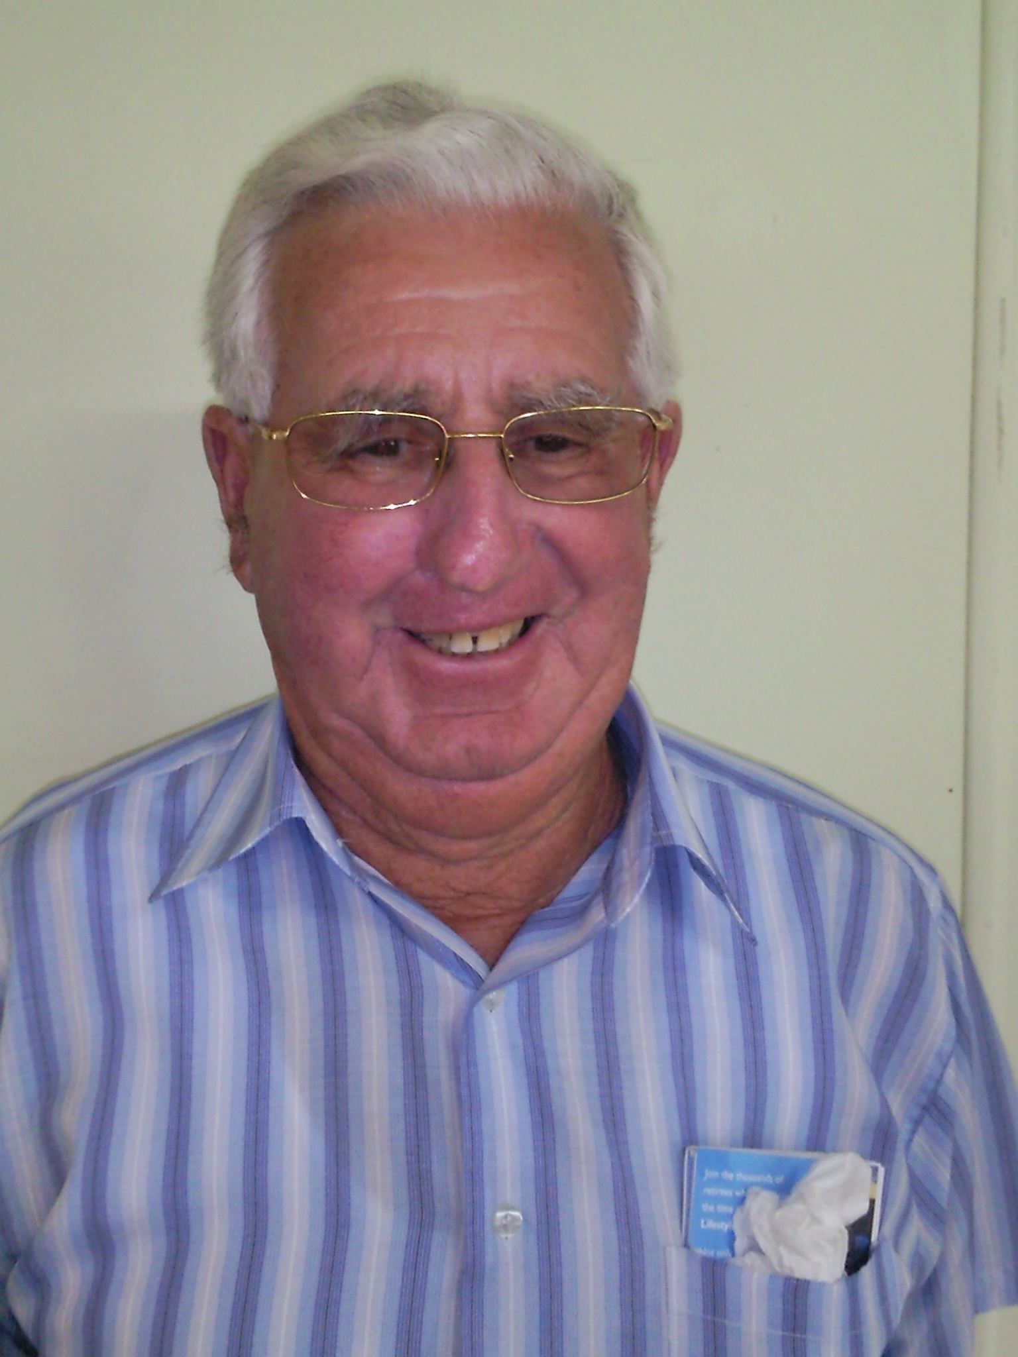 | Merv Miles  Merv is a life member of the HBA, and the current Association Patron. He is a stalwart of the Gumeracha Bowling Club. Merv has served in various capacities on the HBA Executive Committee – including twice as President. Merv is a popular figure in the HBA, and continues to assist with club duties as well as playing Saturday and Wednesday pennants. He is the current HBA Patron, and is well respected for the support he offers to all HBA events.
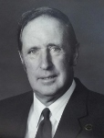 | Noel Green  The late Noel Green was a stalwart of the Lenswood Club. He served three terms as president, won the club singles championship 7 times, and the club pairs on 9 occasions. He was the Association singles Champion in 1981 and 1984, and late in his career picked up the Association pairs title in 1997 with George Thomas. Noel served on the HBA Executive Committee between 1980-86, including two terms as President between 1982-84.
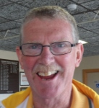 | John McBrien  John took on the role of HBA Secretary/ Treasurer in 1993 – and never imagined that he would go on to serve in that role for 16 years. John cemented his name in HBA history as one of the most astute administrators in the game – and was responsible for many innovations during his terms. He now enjoys the freedom to concentrate on playing – and was rewarded with premiership glory as a member of the 2013/2014 Lobethal Division I team.

